2.1 – Relations and Functions

Domain: _______ values (independent variable; usually _____)
Range: _________ values (dependent variable; usually_______)

Relation: a mapping, or pairing, of input values with output values

Function: if there is exactly one output for each input
(One y for each x)
- Not a function if one x has more than one y

Ordered Pair: x-coordinate and y-coordinate, form (x, y)
[Also a solution of an equation]

Coordinate Plane: Has 4 quadrants, created by the x-axis (horizontal) and the y-axis (vertical) crossing at the origin
Quadrant I
x > 0, y > 0
Quadrant II
x < 0, y > 0
Quadrant III
x < 0, y < 0
Quadrant IV
x > 0, y < 0

Example: Use the mapping diagram to identify the domain and range. Then tell whether the relation is a function. Graph the relations.
Input Output Input Output
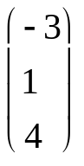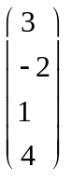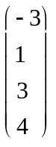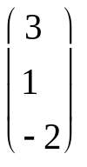

Vertical Line Test
A relation is a function if and only if no vertical line intersects the graph of the relation at more than one point

Examples:
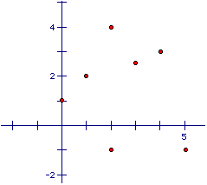
Is this a relation?

Is this a function?

Create a mapping diagram.

Draw a few other examples: (“c”, absolute value, line, etc.)

X | 0 | 1 | 2 | 3 | 4 | 5 | 6
Y | 5 | -3 | 4 | 1 | 2 | -4 | -2
Is this a relation?

Is this a function?

What are the ordered pairs?

Graph the relation.

Quick Quiz: A study was conducted to see if there was a correlation between a child’s age and their IQ. A sample of 11 children between the ages of 5 and 15 were tested for their IQ. The results were graphed:
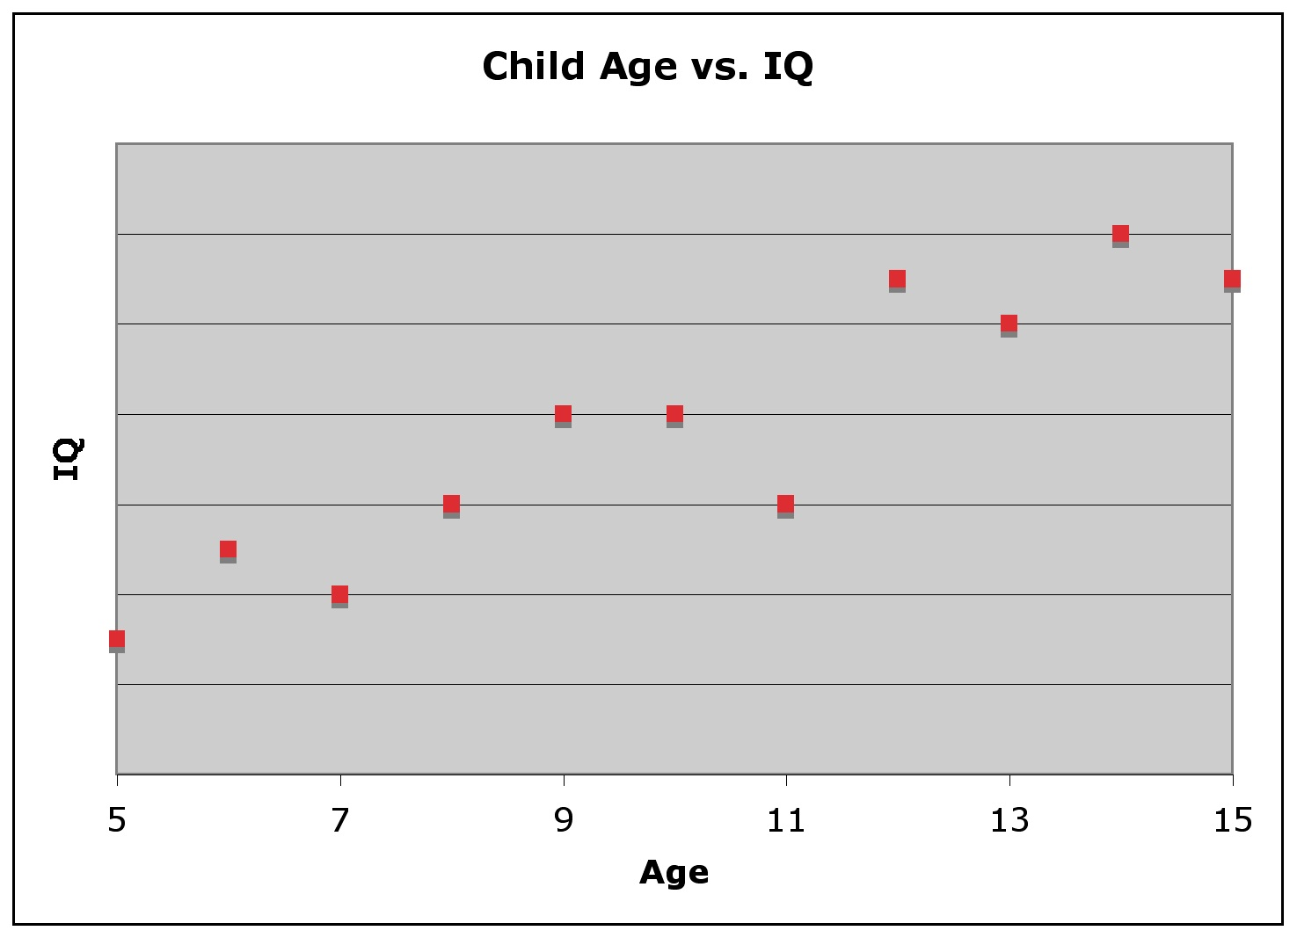
Is this a relation?

Is this a function?

What can we conclude based on these results?

Equation in two variables: a statement equating two expressions containing two variables (usually x and y)

Independent Variable: the input variable

Dependent Variable: the output variable; depends on the value of the input variable

Graphing Equations in Two Variables;
- Construct a table of values (usually a t-chart)
- Graph enough solutions to recognize a pattern
- Connect the points with a line or a curve

Linear Function:

Function Notation:
[Replace y with f(x); pronounced “f of x”]

Examples:
Graph the function, and then evaluate it at the given x:
1. y = x – 1; when x = 20 2. x = 4y; when x = 16

Decide whether the function is linear. Then evaluate at f(-2).
a. f(x) = -x² – 3x + 5 b. f(x) = 2x + 6

Quick Quiz:
Graph and then evaluate the following functions.
1. y = 2x + 5; when x = -10

Determine whether the function is linear, then evaluate when x = 4
2. f(x) = 8 3. y = 3x³ – 4x + 18

A car has a 16-gallon tank. On a long highway trip, gas is used at a rate of about 2 gallons per hour. The gallons of gas g in the car’s tank can be modeled by the equation g = 16 – 2t where t is the time (in hours).

a) Identify the domain and range of the function. Then graph the function.

b) At the end of the trip there are 2 gallons of gas left. How long was the trip?

